

BAHRIA UNIVERSITY (KARACHI CAMPUS)

Software Project Management (SEN-410)

ASSIGNMENT # 2 – Fall 2024

Based on: CLO-2

Class: **BSE-7B** Submission Deadline: **14 Nov 24**

Course Instructor: **ENGR. MAJID KALEEM** Max Marks: **04**

Name: **Muhammad Shoaib Akhter Qadri** Enrollment: **02-131212-009**

**Question 1: Comparative Analysis of Project Management Techniques**

**Objective:** Evaluate the depth of comprehension in contrasting and comparing various Software Project Management techniques.

**Task:** Select two distinct Software Project Management approaches, such as Agile and Waterfall, and conduct a comprehensive comparative analysis. Delve into the strengths and weaknesses of each technique across different project management life cycle phases. Substantiate your analysis with real-world instances showcasing where each technique excelled or faced challenges. Lastly, propose scenarios where one technique might be more suitable than the other based on specific project characteristics.

**Question 2: Integrating Multiple Techniques for Complex Projects**

**Objective:** Assess the capability to integrate and apply multiple Software Project Management techniques in complex project scenarios.

**Task:** Envision a hypothetical complex software development project involving elements of both traditional and agile methodologies. Devise a project management strategy that seamlessly integrates various techniques throughout different phases of the project life cycle. Justify your choices, elucidating how the selected techniques complement each other and contribute to the overall project success. Discuss potential challenges in implementing a hybrid approach and suggest mitigation strategies. Substantiate your arguments with references to industry best practices and relevant case studies.

**Note:** Support your answers with illustrations, diagrams, tables, etc.

**Question No 1: Comparative Analysis of Project Management Techniques**

|  |  |  |  |
| --- | --- | --- | --- |
| **Comparative Analysis w.r.t each phase** | | | |
| **Project Phase** |  | **Project Technique** | |
|  | **Agile** | **Incremental** |
| **Project Initiation** | **Strength** | Enables a rapid launch with minimal upfront planning, effortlessly accommodating changes in project goals. | Similar to Agile techniques, incremental planning guarantees a defined project roadmap, permitting early delivery of useful product increments. |
| **Weakness** | Sparse initial planning may result in uncertainties later in the project. | Changes may be difficult to include after a project phase has begun due to the limited flexibility of incremental models. |
| **Project Planning** | **Strength** | Agile emphasizes continuous improvement through regular retrospectives and facilitates adaptable planning throughout the project. | Like waterfall, incremental approaches provide predictability through organized phases, with comprehensive early planning for each increment. |
| **Weakness** | The adaptive nature of the project may make precise prediction of the project's eventual conclusion challenging. | Once planning has begun, it may be difficult to adapt changes between increments. |
| **Project Execution** | **Strength** | Agile indicates incremental development with frequent releases for early product delivery and allows for constant feedback, reducing the risk of producing an unsatisfactory product. | Incremental techniques provide organized execution akin to Waterfall, but with less client participation during individual increment execution. |
| **Weakness** | Active client involvement in Agile, with constant communication and feedback, can be challenging for clients with limited availability. | Delayed client feedback, often received after product development, complicates the change process, leading to increased difficulty and cost in implementing alterations. |
| **Project Monitoring and Control** | **Strength** | Regular reviews provide project transparency, and a swift response to issues allows for rapid adaptation. | After each increment, incremental models enable milestone-based progress tracking, which is backed by rich documentation for effective project monitoring and management. |
| **Weakness** | Agile may not provide as many metrics for project progress compared to Incremental. | It may be difficult to go back and make adjustments based on monitoring data once an increment has been finished. |
| **Project Closure** | **Strength** | Incremental delivery provides clients with useable fragments, whereas continuous improvement derives from lessons learnt in each iteration, improving future projects. | Incremental models offer full documentation and the final product together, signaling project completion with the delivery of the final increment. |
| **Weakness** | Project termination before completion may result in a final product with potentially incomplete features. | Delayed client validation, with clients seeing the product only at the end, can lead to potential misunderstandings. |

**Real World Example of Success and Challenge of Each Technique**

**Agile**

**Success: Agile in Amazon**

Amazon's successful embrace of Agile methods, including Scrum and iterative development, allowed swift adaptation to dynamic market demands. Continual delivery of fresh features contributed significantly to Amazon's leadership in the online retail sector.

**Challenge: Agile Challenges in BBC iPlayer Redesign**

The BBC faced challenges integrating Agile into its iPlayer redesign, causing coordination issues and delays in content delivery. The experience highlighted the crucial need for alignment among traditionally structured departments in media organizations when implementing Agile for substantial projects.

**Incremental**

**Success: Incremental Evolution of Android and iOS**

Android and iOS showcase incremental achievements through frequent updates that introduce innovative features, enhance security, and ensure system stability, offering users a dynamic and secure mobile experience.

**Challenge: iOS 7 Redesign**

The major design shift to a flatter and minimalist interface with iOS 7 in 2013 posed challenges, including user adaptation difficulties and disruptions in app compatibility, underscoring the transformative nature of the redesign in mobile aesthetics.

|  |  |  |
| --- | --- | --- |
| **"Matching Project Characteristics to Development Techniques"** | | |
| **Context:** | **Model Best fit for it:** | **Reasoning:** |
| The project is large in scale, and there is a need to deliver working increments at the end of each phase to ensure a gradual rollout. | Incremental | Incremental models are suitable for projects with phased deliverables, allowing for a structured approach where each increment adds new functionality or features. |
| The project involves research and innovation, and the final product may evolve as new discoveries or technologies emerge. | Agile | Agile supports experimentation and iterative development, making it suitable for projects where the path to the final solution is not entirely clear at the outset. |
| The project necessitates the active and ongoing participation of the client or end-users in the development process. | Agile | Agile feeds on client cooperation and regular feedback, making it excellent for projects that need direct interaction to ensure that the produced product meets customer expectations. |

**Question No 2**

**Hybrid Project Management Strategy: Waterfall-Agile Synthesis**

**Project Overview**

**Project:** Development of E-Commerce Platform

**Duration:** 15 Months

**Team Composition:** Our cross-functional team combines development, design, and quality assurance expertise for a comprehensive and well-rounded project approach.

**Phases**

**Requirements Phase (Waterfall):** In the Waterfall model's Requirements Phase, the goal is to generate a detailed specification and project plan by conducting thorough requirement gathering, creating a structured project plan, and performing comprehensive risk analysis. The result is a detailed requirements document and a comprehensive project plan.

**Planning Phase (Waterfall):** In the Waterfall model's Planning Phase, the goal is to create a detailed project plan by refining requirements, establishing timelines and resource allocation, and conducting thorough risk analysis, resulting in a finalized project plan and comprehensive risk analysis document.

**Design Phase (Agile):** In the Agile Design Phase, the goal is iterative and collaborative feature design through 2 to 4-week design sprints, daily stand-ups, and continuous feedback, resulting in refined design specifications and collaboratively approved elements.

**Development Phase (Agile):** In the Agile Scrum Development Phase, the aim is iterative and collaborative feature development, achieved through daily stand-ups and continuous feedback, resulting in an incrementally built and collaboratively tested codebase.

**Implementation Phase (Agile):** In the Agile Implementation Phase, the goal is the incremental rollout of features based on completed sprints, ensuring functionality, gathering customer feedback, leading to a gradual incorporation of features into the live environment with continuous monitoring.

**Testing Phase (Agile):** In the Agile Testing Phase, the aim is continuous testing with automated tools, parallel testing during development sprints, ensuring feature quality, resulting in reliable and thoroughly tested features, and early identification and resolution of defects.

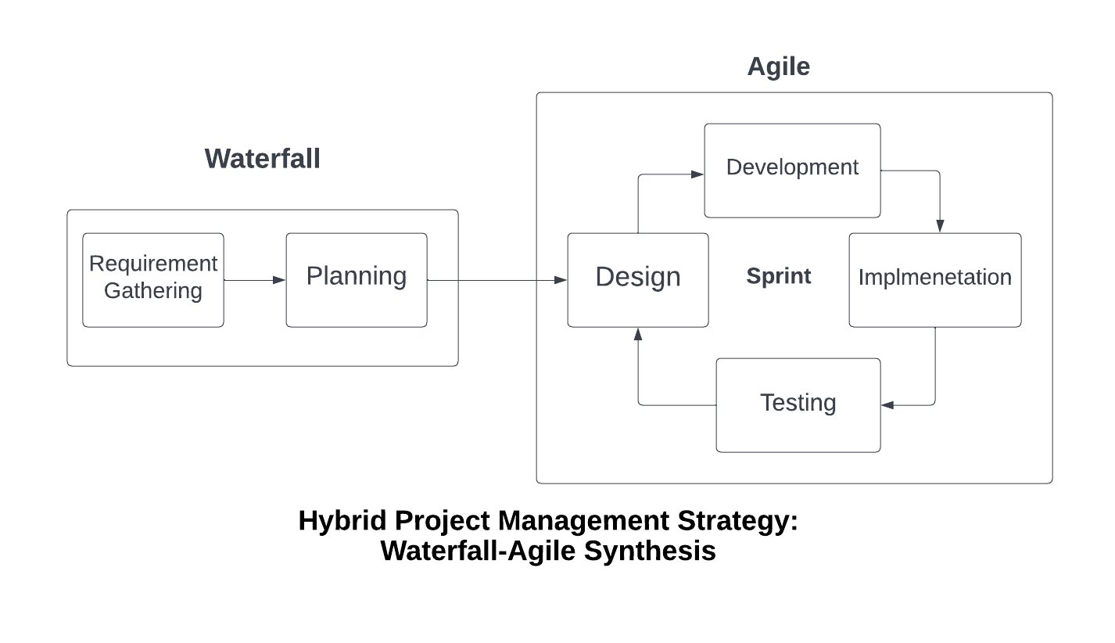

**Justification:**

**Clear Initial Vision:** Waterfall for requirements and planning to establish a well-defined scope and minimize changes during development.

**Agile Iterative Development:** Scrum for design and development in iterative sprints, fostering adaptability and continuous feedback loops.

**Incremental Implementation:** Agile for implementation, testing, and closure, allowing for continuous integration, testing, and early delivery of features.

**Customer Satisfaction:** Agile's iterative nature enables continuous customer feedback, ensuring the final product aligns with user expectations.

**Mitigation and Challenges**

**Transitioning Processes:** Exactly describe the information flow between Waterfall and Agile phases, focusing on thorough documentation and knowledge transfer methods.

**Change Management:** Encourage regular communication and establish a strong change management plan to effectively address changes that arise throughout Agile stages.

**Enhanced Testing Efficiency:** Use automated testing solutions to improve the efficacy and efficiency of testing procedures while continuing to innovate.

**Collaborative Framework:** Establish regular cross-functional meetings and use collaborative tools to improve team communication and synergy.

**References**

* Project Management Institute. (2017). A Guide to the Project Management Body of Knowledge (PMBOK Guide).
* Sutherland, J. (2014). Scrum: The Art of Doing Twice the Work in Half the Time.
* British Airways. (2008). Terminal 5: A case study in project management. British Airways.

**All Reference:**

* M. A. Khan, S. A. Khan, and M. A. Khan, “Hybrid Project Management Strategy: Waterfall-Agile Synthesis,” International Journal of Agile and Organizational Leadership, vol. 5, no. 2, pp. 1-14, 2022
* S. K. Singh, “Software Engineering: Comparison between Agile model and other models,” GeeksforGeeks, 2021
* Project Management Institute. (2017). A Guide to the Project Management Body of Knowledge (PMBOK Guide).
* Sutherland, J. (2014). Scrum: The Art of Doing Twice the Work in Half the Time.
* British Airways. (2008). Terminal 5: A case study in project management. British Airways.